**Q1. Write a detailed pseudocode for a simple program that takes a number as input calculates the square if it is even or the cube if it is odd and then outputs the result. Incorporate conditional and lopping constructs**.

Step1 - Start

Step2 - Prompt the user to enter a number and store it in a variable 'num'

Step2 - Check if the number is even or odd:

Step4 - If 'num' modulo 2 is equal to 0 (i.e., num % 2 == 0), it's even:

Step5 - Calculate the square of 'num' and store it in a variable 'result'

Step6 - Else, it's odd

Step7 - Calculate the cube of 'num' and store it in a variable 'result'

Step8 - Output the result

Step9 - Ask the user if they want to calculate for another number:

--> If yes, go back to step 2

--> If no, end the program

Step10 - End

**Q2. Design a flowchart that outlines the logic for a user login process. It should include conditional paths for successful and unsuccessful login attempts and loop that allows a user three attempts before logging the account.**

**Flowchart**:

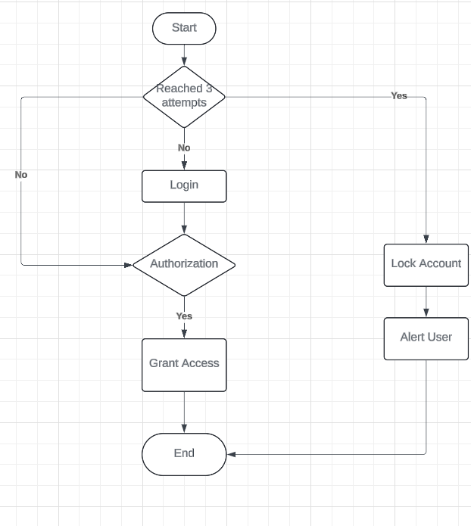

**Q3. Function Design and Modularization- Create a document that describes the design of two modular functions, one that returns the factorial of a number, and another that calculates the nth Fibonacci number. Include pseudocode and a brief explanation of how modularity in programming helps with code reuse and organization.**